**Gene introduction ATH GAI et SPY**

**GAI**

Gibberellic-Acid Insensitive (*GAI)* is a gene in Arabidopsis thaliana in chromosome 1 which is involved in the regulation of plant growth. Precisely, it mediated the input signals and module the growth by decreasing the responsiveness to gibberellin1.

http://genesdev.cshlp.org/content/11/23/3194.short

Gibberellin is a tetracyclic diterpenoid growth factor and influence essentially the stem elongation and other plant developmental processes2.

<https://link.springer.com/article/10.1007%2FBF00016489>

The main mutation involved a deletion of a 17 amino acid segment. The gai allele contains a deletion of 51-bp from within the GAI ORF ,from close to the N terminus and confers a dominant dwarf phenotype. The mutation take place at the DNA-binding transcription factor activity and causes a dwarf phenotype. It acts as a repressor and a coactivator of the zinc finger transcription factors GAF1/IDD2 and ENY/IDD1 in regulation of gibberellin homeostasis and signalling of the gibberellin (GA) signalling pathway. The GAI (*gai1-1 and gai 1-2, two mutations on the same gene)* protein as normally a length of 533 AA and is normally located in the nucleus. The deleted segment is shown in yellow for DELLA, the common one.

doi:10.1101/gad.11.23.3194

<http://genesdev.cshlp.org/content/16/5/646>

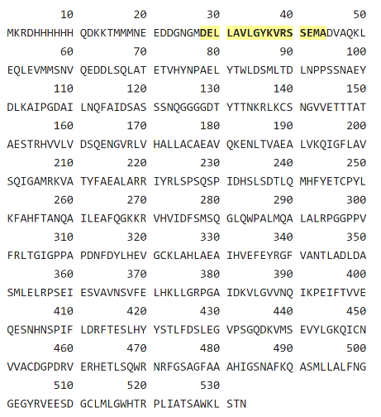

*The DELLA protein GAI comes from the GRAS family protein 3 and located on the chromosome 1, locus:2006747 AT1G14920. Call DELLA because of the 17 AA deleted.*

If it is mutated (*gai)* and the plant growth better, it is a gain of function gene, in contrary it is a loss of function. The cellular *gai’s* component is in the nucleus and is described as a transcription region of DNA and bind it directly. The mutation in SPY (*spy)* is a suppressor of *gai,* conferring to the plant a normal phenotype. GA-deficient Arabidopsis mutants display characteristic phenotypes, including dark green leaves and a dwarf growth habit attributable to reduced stem elongation1.

http://genesdev.cshlp.org/content/11/23/3194.short

The *gai* mutation affects GA reception or subsequent signal transduction and does not result in GA deficiency2.

https://link.springer.com/article/10.1007%2FBF00016489

**SPY**

For spy, three independent recessive mutations at the SPINDLY (SPY) locus of Arabidopsis confer resistance to the gibberellin (GA) biosynthesis inhibitor paclobutrazol4.

Paclobutrazol or α-tert-Butyl-β-(4-chlorobenzyl)-1H-1,2,4-triazole-1-ethanol, is a plant growth retardant. It is an antagonist of the plant hormone gibberellin. It works by inhibiting gibberellin biosynthesis by inhibiting endoplasmic reticulum monooxygenases. Relative to wild type, spy mutants exhibit longer hypocotyls, leaves that are a lighter green colour, increased stem elongation, early flowering, parthenocarpy, and partial male sterility. All of these phenotypes are also observed when wild-type Arabidopsis plants are repeatedly treated with gibberellin A3 (GA3). The spy-1 allele is partially epistatic to the ga1-2 mutation, which causes GA deficiency. In addition, the spy-1 mutation can simultaneously suppress the effects of the ga1-2 mutation and paclobutrazol treatment, which inhibit different steps in the GA biosynthesis pathway. This observation suggests that spy-1 activates a basal level of GA signal transduction that is independent of GA4.

<http://genesdev.cshlp.org/content/16/5/646> (tout le paragraphe vient des résultats de ce paper)

1. Peng J, Carol P, Richards DE, et al. The Arabidopsis GAI gene defines a signalling pathway that negatively regulates gibberellin responses. Genes Dev. 1997;11(23):3194–3205. doi:10.1101/gad.11.23.3194
2. Gibberellins: perception, transduction and responses. Hooley R1.
3. Lee S, Cheng H, King KE, et al. Gibberellin regulates Arabidopsis seed germination via RGL2, a GAI/RGA-like gene whose expression is up-regulated following imbibition. Genes Dev. 2002;16(5):646–658. doi:10.1101/gad.969002
4. Jacobsen SE, Olszewski NE. Mutations at the SPINDLY locus of Arabidopsis alter gibberellin signal transduction. Plant Cell. 1993 Aug;5(8):887-96. Department of Plant Biology, University of Minnesota, St. Paul 55108.